Name: Kainaat Rafiq Hussain Makhani
Registration #: 2012296
Semester and Section: 7A
LAB 6
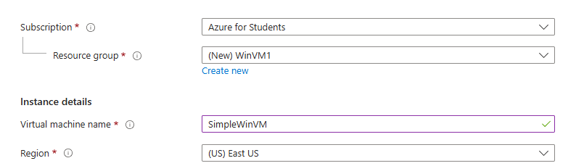

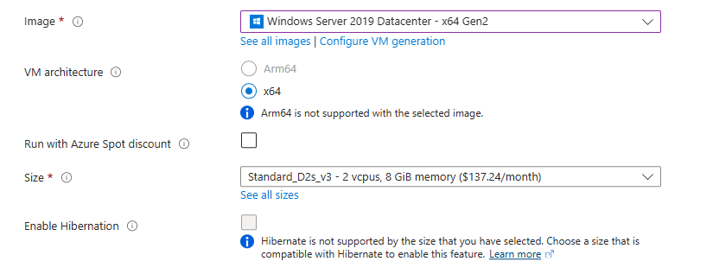

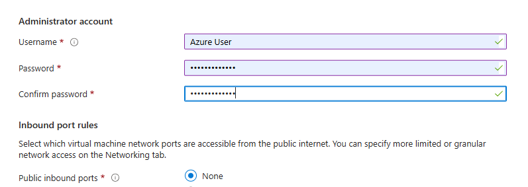

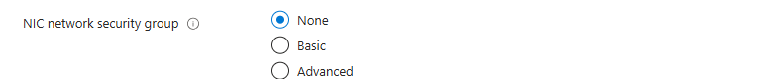

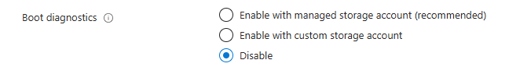

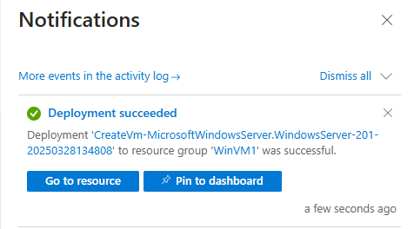

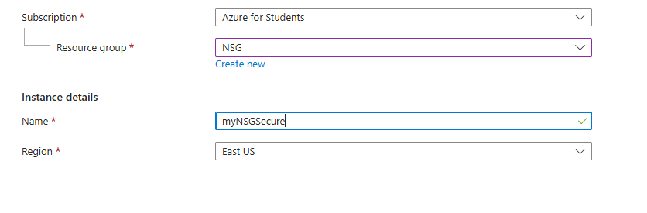

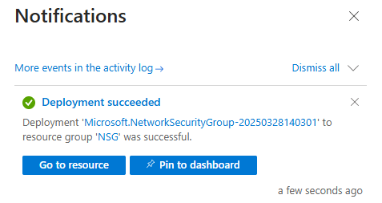

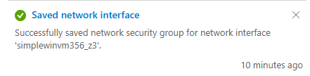

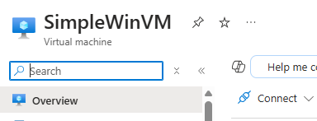

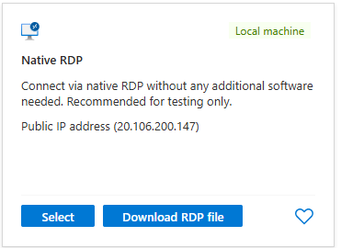

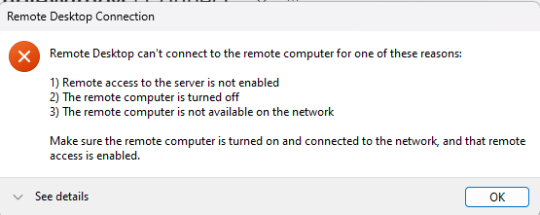

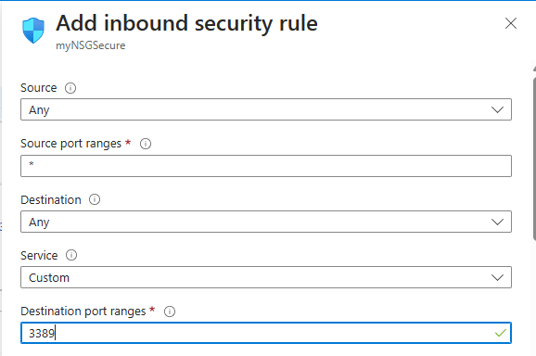

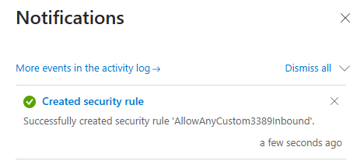

Description:
In this task, you will secure network traffic for a virtual machine (VM) by configuring a network security group (NSG). The steps include creating a Windows Server 2019 VM, configuring inbound and outbound security rules, and testing the rules. The process involves allowing RDP traffic by adding an inbound port rule and denying internet access by creating an outbound security rule. Finally, to avoid extra costs, you can delete the resource group that was created for the VM and network security group.

